SIMULATION EXPERIMENT – 2
2. Design and Performance Analysis of Chebyshev Type-I IIR Low-Pass and High-Pass Filters Using MATLAB
Objectives of this Experiment:
1. To design Chebyshev Type-I IIR low-pass and high-pass filters for specified digital frequency requirements.
2. To study the effect of passband ripple on filter order and frequency response.
3. To obtain and analyze filter coefficients, magnitude and phase responses.
4. To compare the Chebyshev Type-I response with the corresponding Butterworth response.
Program Code:
clear; clc; close all;

% Design Parameters
Fs = 10000; % Sampling frequency in Hz
Ap = 0.5; % Passband ripple in dB
As = 30; % Stopband attenuation in dB

% 1. Low-Pass Filter Design
fp_lp = 1500; % Passband frequency (Hz)
fs_lp = 2000; % Stopband frequency (Hz)
wp_lp = fp_lp / (Fs/2);
ws_lp = fs_lp / (Fs/2);

[N_lp, Wn_lp] = cheb1ord(wp_lp, ws_lp, Ap, As);
[b_lp, a_lp] = cheby1(N_lp, Ap, Wn_lp, 'low');

% 2. High-Pass Filter Design
fp_hp = 2500; % Passband frequency (Hz)
fs_hp = 1800; % Stopband frequency (Hz)
wp_hp = fp_hp / (Fs/2);
ws_hp = fs_hp / (Fs/2);

[N_hp, Wn_hp] = cheb1ord(wp_hp, ws_hp, Ap, As);
[b_hp, a_hp] = cheby1(N_hp, Ap, Wn_hp, 'high');

% ==========================================
% DISPLAY NUMERICAL OUTPUTS IN COMMAND WINDOW
% ==========================================
fprintf('=== EXPERIMENT 2: CHEBYSHEV TYPE-I IIR FILTERS ===\n\n');

fprintf('--- CHEBYSHEV LOW-PASS FILTER ---\n');
fprintf('Calculated Filter Order (N_lp): %d\n', N_lp);
fprintf('Passband Edge Cutoff Frequency (Wn_lp): %.4f Hz\n', Wn_lp * (Fs/2));
fprintf('Numerator Coefficients (b_lp):\n');
disp(b_lp);
fprintf('Denominator Coefficients (a_lp):\n');
disp(a_lp);

fprintf('--- CHEBYSHEV HIGH-PASS FILTER ---\n');
fprintf('Calculated Filter Order (N_hp): %d\n', N_hp);
fprintf('Passband Edge Cutoff Frequency (Wn_hp): %.4f Hz\n', Wn_hp * (Fs/2));
fprintf('Numerator Coefficients (b_hp):\n');
disp(b_hp);
fprintf('Denominator Coefficients (a_hp):\n');
disp(a_hp);

% Frequency Response Calculation
[H_lp, f] = freqz(b_lp, a_lp, 1024, Fs);
[H_hp, ~] = freqz(b_hp, a_hp, 1024, Fs);

% Plotting
figure('Name', 'Chebyshev Type-I LPF and HPF Responses');
subplot(2,2,1);
plot(f, 20*log10(abs(H_lp)), 'b', 'LineWidth', 1.5); grid on;
title(['Chebyshev LPF Magnitude (Order N = ', num2str(N_lp), ')']);
xlabel('Frequency (Hz)'); ylabel('Magnitude (dB)'); ylim([-60 5]);

subplot(2,2,2);
plot(f, angle(H_lp)*180/pi, 'r', 'LineWidth', 1.5); grid on;
title('Chebyshev LPF Phase Response');
xlabel('Frequency (Hz)'); ylabel('Phase (degrees)');

subplot(2,2,3);
plot(f, 20*log10(abs(H_hp)), 'b', 'LineWidth', 1.5); grid on;
title(['Chebyshev HPF Magnitude (Order N = ', num2str(N_hp), ')']);
xlabel('Frequency (Hz)'); ylabel('Magnitude (dB)'); ylim([-60 5]);

subplot(2,2,4);
plot(f, angle(H_hp)*180/pi, 'r', 'LineWidth', 1.5); grid on;
title('Chebyshev HPF Phase Response');
xlabel('Frequency (Hz)'); ylabel('Phase (degrees)');

OUTPUT:
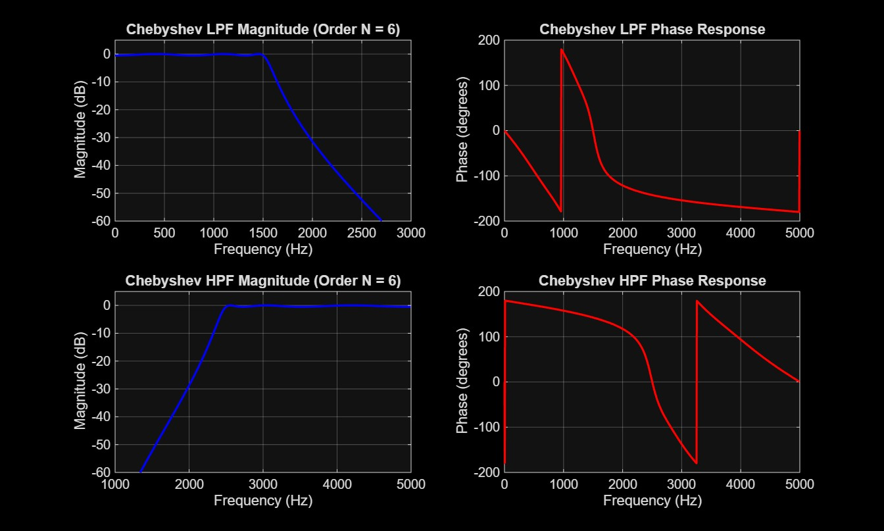
RESULT:
=== EXPERIMENT 2: CHEBYSHEV TYPE-I IIR FILTERS ===

--- CHEBYSHEV LOW-PASS FILTER ---
Calculated Filter Order (N_lp): 6
Passband Edge Cutoff Frequency (Wn_lp): 1500.0000 Hz
Numerator Coefficients (b_lp):
0.0006 0.0038 0.0095 0.0127 0.0095 0.0038 0.0006

Denominator Coefficients (a_lp):
1.0000 -3.7650 6.8198 -7.3274 4.8717 -1.8927 0.3368

--- CHEBYSHEV HIGH-PASS FILTER ---
Calculated Filter Order (N_hp): 6
Passband Edge Cutoff Frequency (Wn_hp): 2500.0000 Hz
Numerator Coefficients (b_hp):
0.0117 -0.0704 0.1761 -0.2348 0.1761 -0.0704 0.0117

Denominator Coefficients (a_hp):
1.0000 1.3568 2.1347 1.8511 1.2978 0.5937 0.1650

